**How to use the Pixhawk and GPS system**

**Step 1:**

Make the following connections to connect the Pixhawk to the Raspberry Pi using UART connection:

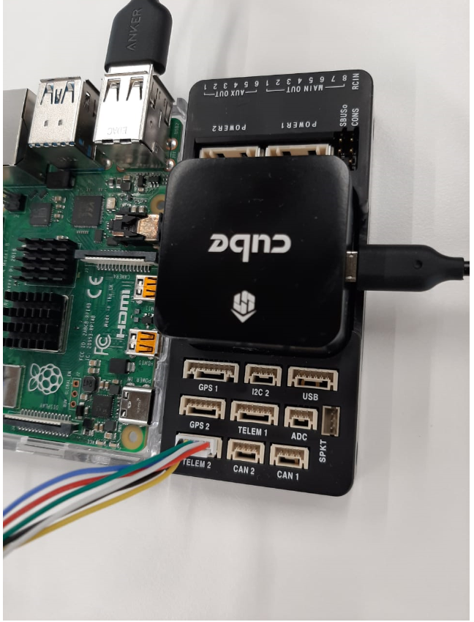

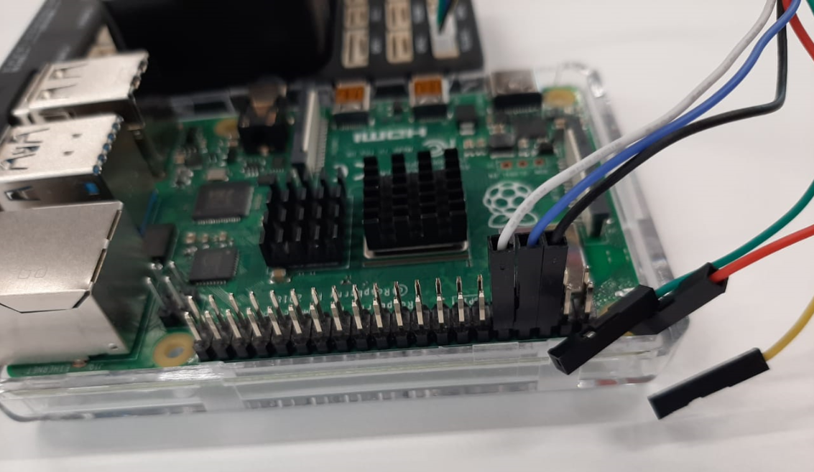

Wire from the Pixhawk: BLACK – GND; BLUE – RX; WHITE – TX   
When connecting the TX and RX from the Pixhawk, remember it goes into the opposite ports of the RPi. For example:

**RPi TX – Pixhawk RX  
RPi RX – Pixhawk TX**

Connect the USB cable from the Pixhawk to your laptop running mission planner.

**Step 2:**

Connect to mission planner on your PC with the Pixhawk in the rover. This connection will be done using telemetry.

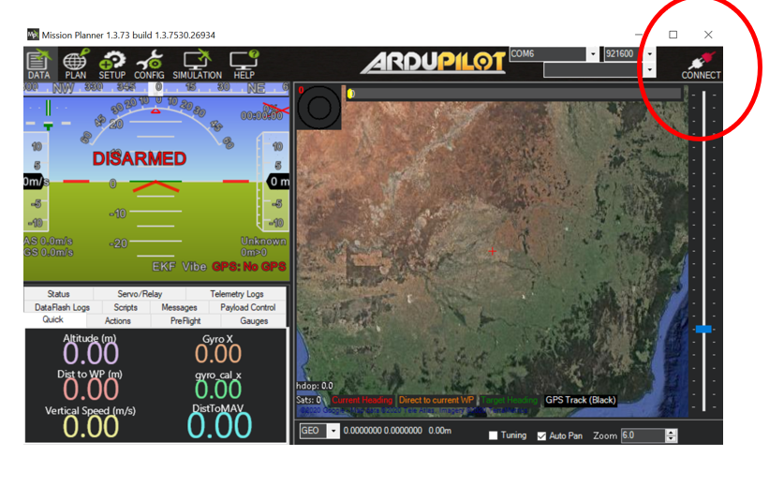

**Step 3:**

Open terminal window on your Raspberry Pi and run the “IMU_GPS_data_collection_storage” python script using the following command:

python IMU_GPS_data_collection_storage

This script will start sending GPS data to the database which can be accessed using:

username: root

password: dewa123

This script will also create a new .csv file and start storing IMU data.

The data will keep being transferred until the Pixhawk or GPS loses connection.

**Step 4:**

To stop the script from running press CTRL+C to cause keyboard interrupt.